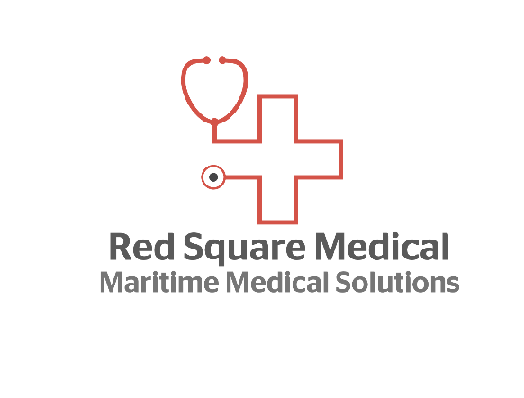
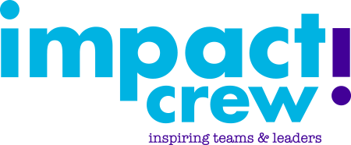

Stress Happens!...
“Stress Happens!” is the brainchild of Crew Health partners Liz Baugh of Red Square Medical and Karen Passman of Impact Crew. The training workshop, developed in 2019 is a response to the increasing awareness of issues affecting crew mental wellbeing whilst onboard.
Unlike other workshops, both Liz and Karen wanted to deliver a style of workshop that encouraged participants to actively take part in learning about their own stress, identifying solutions and ultimately managing it successfully. The end goal was to help participants understand and cope with their own stress before it became anything more than a small blip in an otherwise normal and mentally healthy life in the workplace.
The planning and design of the workshop drew on current evidential research of the causes of stress within the maritime sector, along with other related sectors. Impact Crew and Red Square Medical felt that they needed further input to ensure that this workshop fully met the needs of the crews and shoreside staff who would be taking part.
As both companies are partnered with the Crew Health division of the UK P&I Club, they approached the Crew Health Director, Sophia Bullard in early in 2019 following a Maritime Wellness round table at which they had all been present. Liking what she saw Sophia offered Liz and Karen an open invite to host the pilot workshop.
In June 2019 the UK Club office held the pilot of the “Stress Happens!” workshop to an industry wide audience including: the seafaring charities, management companies, Masters, recruitment agencies, trade unions, MNTB, UK Chamber of Shipping, shipping companies and journalists from maritime publications.
The pilot was judged to be a great success by all those who attended and their feedback provided useful instruction on how to refine the workshop to what is now not just fit for purpose, but leading in its design, development and delivery.
Eight months later we caught up with Liz and Karen to find out what had happened with “Stress Happens!” following the pilot…
What happened next?
The launch to the Superyacht sector during the Monaco Yacht Show saw the start of the first bookings and delivery of the workshop ‘Stress Happens!’ which has been very well received:
“It is really good to start this type of conversation in this industry as it is an extremely stressful place with a lot of crew from around the world. This can sometimes be the main cause of stress by itself! It is also great to do it as a team.”
“Very informative presentation interspersed with activities so it never got boring. Hopefully it was a big help to all the crew. We need lots more of this kind of informative and realistic courses in the yachting industry as stress and mental health issues are rife.”
“Both facilitators had relevant knowledge and experience in the maritime setting. This is not the case with a lot of Yachting course providers so it was refreshing.”
Stress Happens! is a great way of providing a useful tool kit for crew and shoreside staff. It helps build awareness of yourself and others and looks at stress in a realistic way.
For further information on Stress Happens!, please contact Liz Baugh of Red Square Medical or Karen Passman of Impact Crew

