LAID-UP DECLARATION AND RETURN OF CALL APPLICATION

Claims for Laid-up Returns may be submitted in accordance with Rule 27. The Managers will also provide further guidance on the Club’s policy about Call returns.

Members are reminded of the requirements and the effects under Rule 5R, including to give notice to the Managers if the ship is to be recommissioned not less than seven days before the ship leaves the place of lay-up.

Members should draw their attention to Rule 5L and Rule 7 concerning the exclusion of the Insurance Act 2015 to the extent it applies to this insurance.

Please provide the following information to assist the Managers to determine the appropriate return of Calls. Members should provide any additional information which is relevant, or use a separate page if the space below is inadequate.

Name of Ship |  | Gross Tonnage |  | IMO Number
Date Lay-Up Commenced |  | Date Lay-Up Ceased (e.g. date crew commenced joining ship prior to sailing from lay-up berth or loading cargo)
Was any Cargo on Board? |  | For Tankers or Gas ships: was a Gas-Free Certificate Issued?
Place of Lay-Up (Port & Country, including latitude and longitude if known)
Are or were Seamen on board the vessel at any time during lay up? If so, how many and for what periods?
Were any Seamen serving on board before lay up still employed under permanent employment contracts (so called 24/7 contracts) previously approved by the Club? If so, were the Seamen ashore during lay up?

Were personnel other than Seamen on board during lay up? |  |  | Were repairs undertaken during lay up?
Is the Member aware of any claims or incidents which may give rise to claims under the Club’s Rules arising during the period of lay up?
Please indicate which authority or authorities approved the lay up arrangements e.g. Class, the Salvage Association or Port Authority. Please provide documentation.
We request a laid up return of call based on Rule 27 and warrant that the above information is accurate.
Signature | Capacity (Director, Authorised Agent, etc.)
Name Dated | Company Name (on behalf of Member)
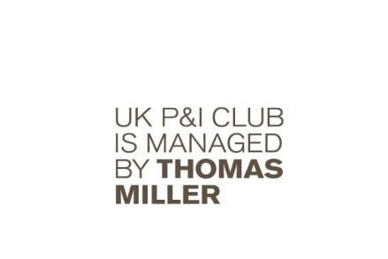

The United Kingdom Mutual Steam Ship Assurance Association (Europe) Limited. Registered in England No.22215.
Thomas Miller P&I (Europe) Ltd. Registered in England No. 2920387. Registered offices as above
UK P&I Club N.V., a public limited liability company (naamloze vennootschap) incorporated in the Netherlands having its registered office at Wilhelminakade 953A, Rotterdam, 3072 AP, The Netherlands

