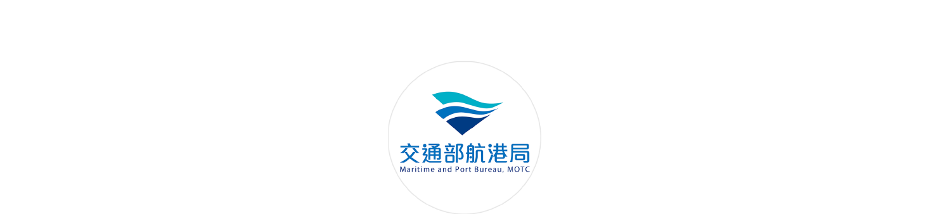
Notice to Mariners,
Maritime and Port Bureau, MOTC

August 3, 2022
257 Response Measures to the Military Exercises Announced by People's Republic of China (PRC) in the Waters Around Taiwan (Northern Taiwan)
Source: In accordance with the information released by the Xinhua News Agency and other media on August 2, 2022.
Details:
- Regarding the important military exercises conducted by PRC from 12:00 on August 4 to 12:00 on August 7, 2022, vessels are urged to avoid the areas where the exercises are being held. Vessels should enter and exit the Port of Keelung, the Port of Su’ao, and the Port of Taipei by using alternate routes, and should pay attention to navigation safety.
- Vessels sailing between the waters west of Area 1 and Pingtan should endeavor to avoid the area where the exercises are being conducted and the surrounding waters in order to ensure navigation safety.

Area 1 coordinates:
A 25°15′26″N, 120°29′20″E
B 24°50′30″N, 120°05′45″E
C 25°04′32″N, 119°51′22″E
D 25°28′12″N, 120°14′30″E

Area 2 coordinates:
E 26°07′00″N, 121°57′00″E
F 25°30′00″N, 121°57′00″E
G 25°30′00″N, 121°28′00″E
H 26°07′00″N, 121°28′00″E

Area 3 coordinates:
I 25°34′00″N, 122°50′00″E
J 25°03′00″N, 122°50′00″E
K 25°03′00″N, 122°11′00″E
L 25°34′00″ N, 122°11′00″E

Location
25°15'26.0"N, 120°29'20.0"E
24°50'30.0"N, 120°05'45.0"E
25°04'32.0"N, 119°51'22.0"E
25°28'12.0"N, 120°14'30.0"E
26°07'00.0"N, 121°57'00.0"E
25°30'00.0"N, 121°57'00.0"E
25°30'00.0"N, 121°28'00.0"E
26°07'00.0"N, 121°28'00.0"E
25°34'00.0"N, 122°50'00.0"E
25°03'00.0"N, 122°50'00.0"E
25°03'00.0"N, 122°11'00.0"E
25°34'00.0"N, 122°11'00.0"E *WGS 84
Maritime and Port Bureau, MOTC
Director-General Yeh Hsieh-Lung

