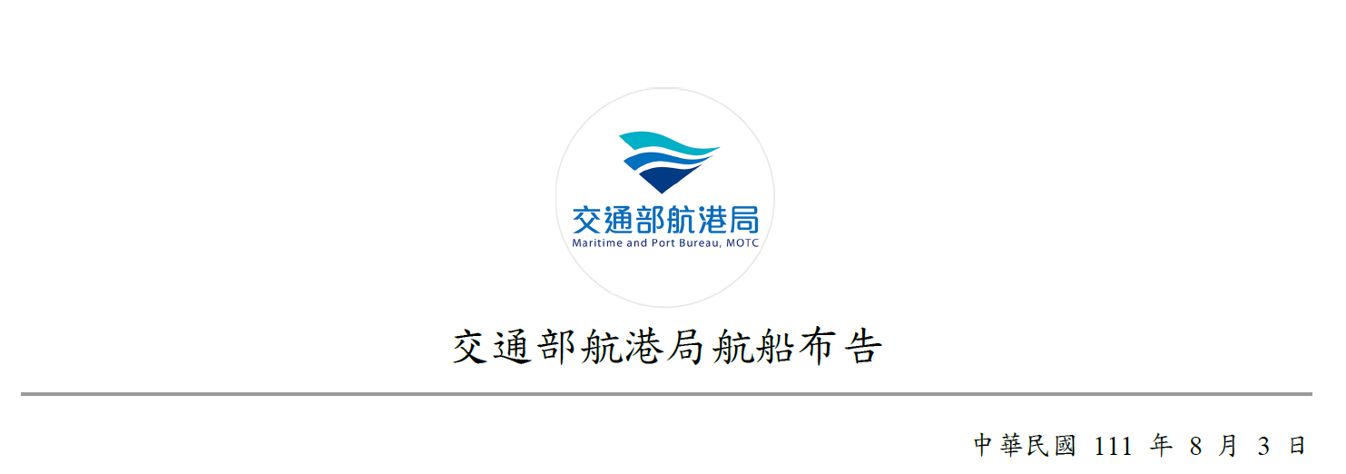

Notice to Mariners,

Maritime and Port Bureau, MOTC

August 3, 2022

|  |  |
| --- | --- |
| 259 | Response Measures to the Military Exercises Announced by People’s Republic of China in the Waters Around Taiwan (Eastern Taiwan) |
| Source： | In accordance with the information released by the Xinhua News Agency and other media on August 2, 2022. |
| Details： | Regarding the important military exercises conducted by PRC from 1200 on August 4 to 1200 on August 7, 2022, vessels are urged to avoid the areas where the exercises are being held. Vessels should enter and exit the Port of Hualien and the Port of Hoping by using alternate routes, and should pay attention to navigation safety. |

Eastern waters location coordinate：

|  |  |  |  |
| --- | --- | --- | --- |
| A | 22°56′00″ N | 122°40′00″ E |  |
| B | 23°38′00″ N | 122°51′00″ E |  |
| C | 23°38′00″ N | 123°23′00″ E |  |
| D | 22°56′00″ N | 123°09′00″ E | (Four Point connection) |

Location coordinate：

|  |  |  |
| --- | --- | --- |
| 22°56'00.0" N | 122°40'00.0" E |  |
| 23°38'00.0" N | 122°51'00.0" E |  |
| 23°38'00.0" N | 123°23'00.0" E |  |
| 22°56'00.0" N | 123°09'00.0" E | (WGS 84 Datum) |

Maritime and Port Bureau, MOTC

Director-General Yeh Hsieh-Lung